1. Text

   Description automatically generated  
   
2. In the earlier lectures, we talked about Kafka Broker, Kafka Cluster and Kafka Architecture.  
   That is great!!!
3. However, sending data streams to Kafka is your first step for using Apache Kafka.
4. Hence, we dedicate this one full session for sending data to Kafka using **Kafka Producer Api**.
5. 
6. Kafka Producer API was primarily made available in Java.
7. In this course we will be using Java API.
8. However, the API is available in other languages.  
   All those language bindings follow the same structure as Java APIs.  
   Some of the most commonly used languages are listed here.  
   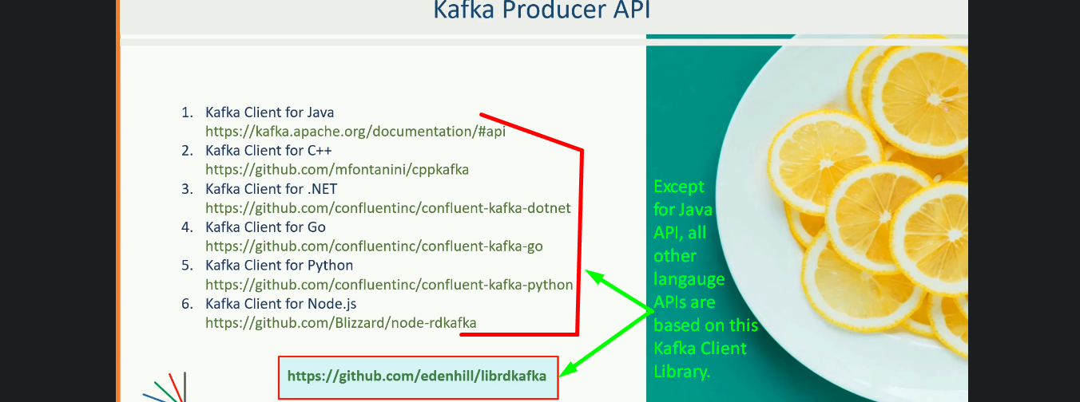  
   There are many other language bindings that are implemented by Open-Source Community.  
   But except for Java API, all the above language APIs are based on C/C++ Library named **librdkafka** as you can see in the above snapshot at bottom.